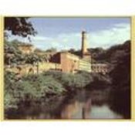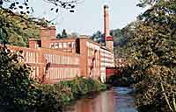

Masson Mills (Masson Mills Shopping Centre)
Masson Mills Shopping Centre

Advantages: Lovely shopping environment.
Disadvantages: Easy to drive past.

The Masson Mills Shopping Centre is situated between Cromford and Matlock Bath on the A6 in Derbyshire.
This centre has been established in the magnificent Arkwright Mills building which was built in 1783. When you drive into the centre there appears to be one very small car park, but there are ramps, which take you to the large 200 space multi-level car park underneath the Mills. The car park is pay and display, but your fee is refunded if you buy anything from the restaurant or tea room.
There are about 15 shops spread over the four floors which has a wonderful “old meets new” feeling about the building. You can sense the history of this imposing building and also within the complex is the Working Textile Museum. Although we have been to the shops many times we haven’t yet been to the museum. (Admission for adults – £2.50, children - £1.50).
The shops are a mixture of clothing, glassware, toiletries, linen/towels, shoes, golf equipment, nuts/dried fruit, toys, candles, all set in the very spacious refurbished surroundings. The large stairway in the middle of the centre connects all the floors and allows some wonderful smells to drift around the building. (There are also lifts between the car park and all floors).
On the Ground floor is the Derwent Restaurant, which serves meals and snacks. The restaurant has huge windows overlooking the River Derwent which originally was the power source for the mills using a waterwheel. After looking around the centre you can talk a stroll along the river with the riverside walk. At the far end of the complex is the Arkwright Tea Room, this more secluded quaint room provides an ideal refuge from shopping.
Both the shopping complex and museum are open seven days a week and if you would like some more information you can look on their website at:
http://www.massonmills.co.uk

When you are driving to this centre look for a large mill, as it does no
t look like a shopping centre at all from the outside, as the building has been preserved in its original glorious condition.
This is a very pleasant shopping centre in a magnificent setting. Well worth a visit.

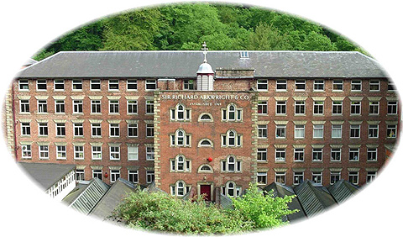

Masson Mill

1783 - Listed Grade II*

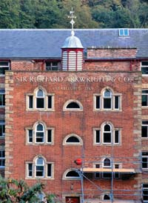
Masson Mill proclaims Arkwright’s growing wealth and self confidence. Unlike the mills at Cromford, it is built on a major river, the river Derwent, which offered Arkwright the opportunity of a power source ten times greater than he enjoyed at his Cromford site. Externally, its design reflects a deliberate movement towards conscious architectural style, and its overall layout, incorporating the staircase and ancillary services in a central
Sir Richard Arkwright’s Masson Mills
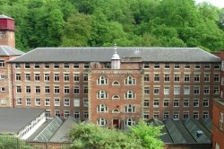
Sir Richard Arkwright's 1783 showpiece Masson Mills on the River Derwent at Matlock Bath are the finest and best preserved example of an Arkwright cotton mill. The Masson Mill pattern of design was influential in nascent British and American cotton mill construction. Working Textile Museum with authentic historic working machinery illustrating Arkwright's Legacy. Gateway to the Derwent Valley Mills World Heritage Site.
Derby Road
Matlock Bath
Derbyshire DE4 3PY
England

Website
www.​massonmills.​co.​uk

Telephone
Museum Reception
01629 ​581001

Every day at 10am, the clattering looms herald the opening of the Working Textile Museum in Sir Richard Arkwright's 1783 Masson Mills. Situated on the River Derwent at Matlock Bath, Derbyshire, Masson Mills are the best preserved and finest surviving example of an Arkwright mill and form the northern gateway to the Derwent Valley Mills World Heritage Site.
Arkwright was renowned as the "Father of the Factory System". His first mill, built in Nottingham in 1769, was followed by mills all over Britain. Then, in 1783 at the height of his entrepreneurial power, he built his showpiece Masson Mills.
Masson Mills Working Textile Museum illustrates Arkwright's Legacy. Here you can experience the authentic atmosphere of an 18th Century cotton mill, watching as cotton yarn is transformed into cloth on some of the oldest working looms in the world and seeing thread being doubled onto bobbins from the largest bobbin collection in the world. Car park, shopping village and restaurant on site.
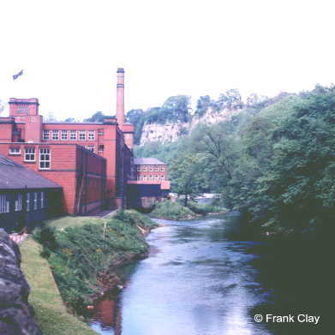
Photograph of Masson Mill beside the River Derwent in Matlock Bath
Reproduced with the kind permission of Frank Clay

http://www.andrewspages.dial.pipex.com/matlock/mills.htm

